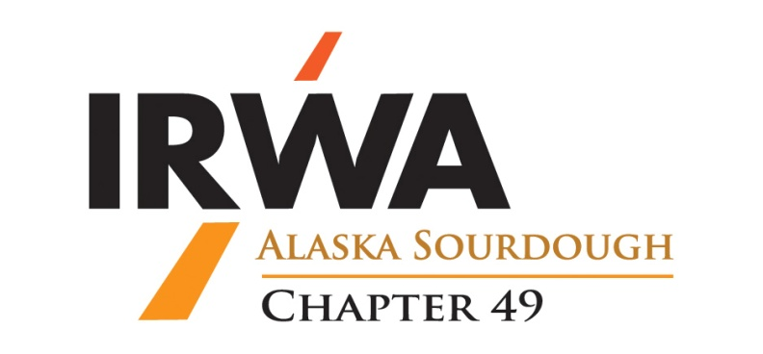
OFFICIAL NOMINATION FORM
FOR THE
PROJECT OF THE YEAR AWARD

The project must be a Right of Way project that included employees, who are members of the International Right of Way Association. The project must demonstrate achievement of high standards of project quality in one or more Right of Way disciplines. Winners of the 3 (three) previous years are not eligible.

Please answer as many questions as apply. You may add an additional page of responses if necessary. It may be helpful to contact other committee chairs for assistance for some the requested information. Please submit forms by email to sterling.lopez@enstarnaturalgas.com or by mail to the address at the bottom of this form. If you have not received confirmation of the nomination within 48 hours, please call the number at the bottom of this form.

► Nominations must be received by January 15th ◄

NAME OF ORGANIZATION(s):

NAME OF PROJECT:

NOMINATED BY:
PHONE NUMBER:________________________CHAPTER NUMBER: 49 REGION: 7

Describe IRWA members’ involvement in the project:

Identify Owner/Client’s project goal/s and give examples of how the project met Owner/Client’s need/s and expectation/s:

How did project meet or improve on budget and schedule performance when compared with the original established budget and schedule goals?

Describe originality and uniqueness of applied project techniques, including innovative application of practices/methods:

Describe complexity of the project and unusual conditions, issues, and barriers requiring special project team action and performance. Examples might be:
- Team staffing and/or any special resources required
- Impediments or constraints overcome
- Legal issues resolved or complied with
- Location of project -- remoteness, weather and/or accessibility challenges
- Budgetary considerations to accomplish project
- Property owners/agencies or other stakeholders involved with the project
- Eminent domain litigation issues
- Legal precedents established as a result of project

Describe the outcome of the project and resulting effect on the affected Property Owners, the Owner/Client, the Community and/or others:

PROJECT MANAGER: PHONE:

PROJECT OWNER/CLIENT:

Email To: | Sterling.lopez@enstarnaturalgas.com
Mail To: | IRWA Chapter 49  C/O ENSTAR Natural Gas Company – ATTN: Sterling Lopez, ROW  PO Box 190288, Anchorage, AK 99519
Call: | (907) 334-7911

