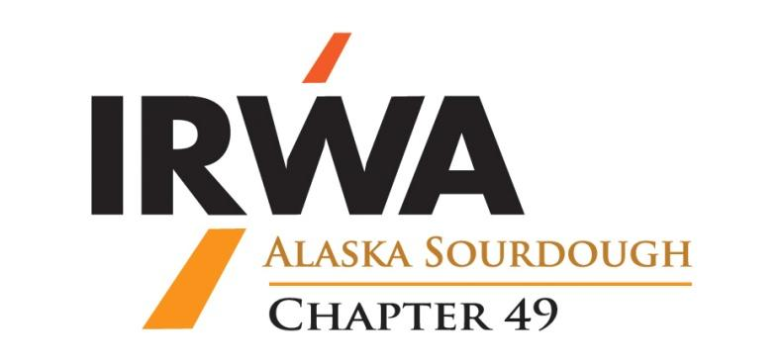

OFFICIAL NOMINATION FORM
FOR THE
PROFESSIONAL OF THE YEAR AWARD

The nominee must be a member of the International Right of Way Association that demonstrates high professional standards in their Right of Way field. To qualify as a candidate for the award, a nominee must have made outstanding contributions to the Association and provide support to other members and Right of Way professionals. Winners of the 3 (three) previous years are not eligible.

Please answer as many questions as apply. You may add an additional page of responses if necessary. It may be helpful to contact other committee chairs for assistance for some the requested information. Please submit forms by email to sterling.lopez@enstarnaturalgas.com or by mail to the address at the bottom of this form. If you have not received confirmation of the nomination within 48 hours, please call the number at the bottom of this form.

► Nominations must be received by January 15th ◄

NOMINEE’S NAME:

NOMINATED BY:
PHONE NUMBER: ________________________CHAPTER NUMBER: _____REGION:______

IRWA PARTICIPATION
- Chapter/Regional Offices held:
- Chapter/Regional Committee/s:

- Other:

CHAPTER SUPPORT
- Projects:
- Attendance at Meetings:
- Committee Activities:

SEMINAR / CONFERENCE ATTENDANCE AND PARTICIPATION
- International conference attendance (years):
- Regional or Chapter seminar program participation (year):
- Other:
PROFESSION
- Special projects related to ROW Profession:
- Special recognition from Employer:
- Other:

EDUCATIONAL COURSES AND ACTIVITIES
- IRWA and other professional courses completed:
- IRWA and other professional courses organized or instructed:
- Other professional education:

IRWA PROFESSIONAL DESIGNATION
- Candidate for SR/WA:
- SR/WA designation:
- Voluntary re-certification:

EXTRA-CURRICULAR ACTIVITIES
- Other professional memberships:
- Civic memberships:
- Leadership roles or special accomplishments in the above organizations:
- Other:

Email To: | Sterling.lopez@enstarnaturalgas.com
Mail To: | IRWA Chapter 49  C/O ENSTAR Natural Gas Company, ATTN: Sterling Lopez, ROW  PO Box 190288, Anchorage, AK 99519
Call: | (907) 334-7911

